**https://akbuilders.business.blog/2023/10/19/ak-builders/**

**[SITE TITLE](https://akbuilders.business.blog/)** [Home](https://akbuilders.business.blog/)

[October 19, 2023](https://akbuilders.business.blog/2023/10/19/ak-builders/) · U [ncatego rized](https://akbuilders.business.blog/category/uncategorized/)

AK Builders

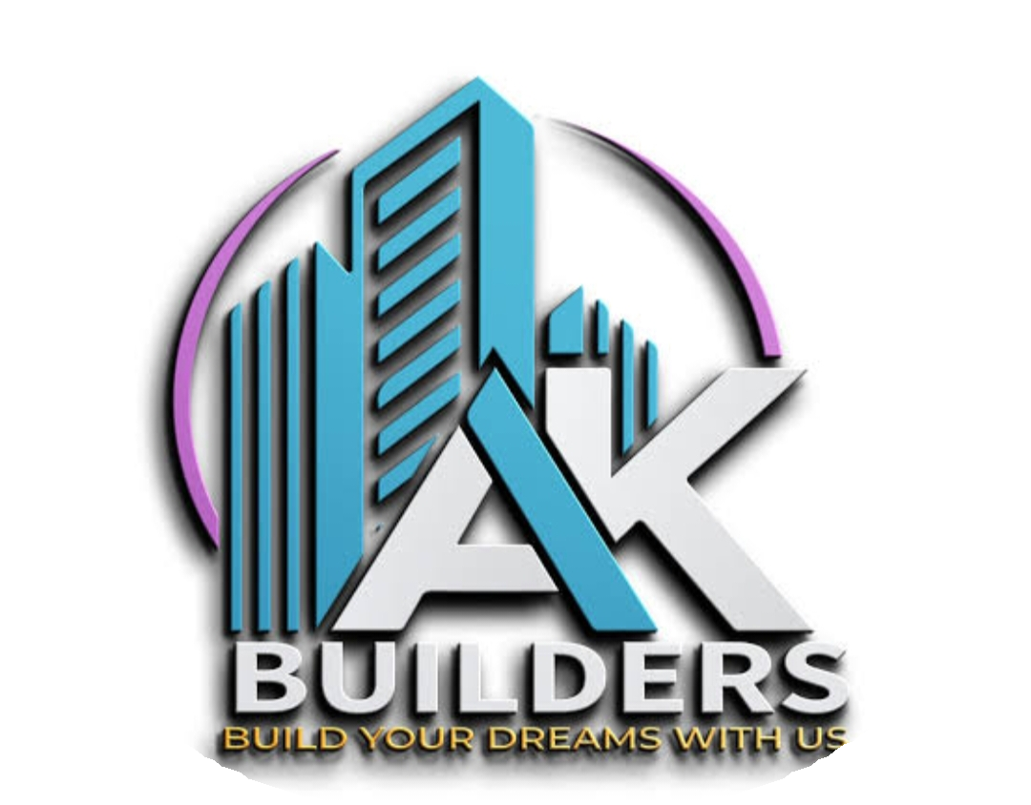

# ABOUT OUR COMPANY:

Introducing “**AK Builders**” – Your Trusted Partner in Construction!

Are you dreaming of your ideal home or envisioning a cutting-edge commercial space? Look no further!

At **AK Builders**, we turn your construction dreams into reality. With years of experience and a commitment to excellence, we’re the construction company you can trust.

Why Choose **AK Builders**?

✅ Expertise in Residential & Commercial Construction

✅ Skilled Architects, Engineers, and Craftsmen

✅ Innovative Designs & Sustainable Solutions

✅ Timely Project Delivery

✅ Competitive Pricing

Let’s build your future together! Contact us today for a free consultation and turn your vision into a concrete reality with **AK Builders**. #BuildWithAkbuilders #ConstructionExcellence

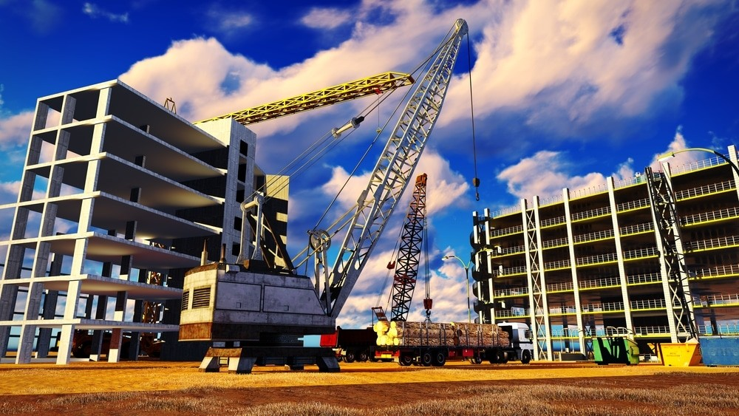

A construction company is a business entity that specializes in planning, managing, and executing various construction projects. These projects can include building residential and commercial structures, infrastructure development, renovations, and more. Construction companies typically employ architects, engineers, project managers, and skilled laborers to ensure that construction projects are completed efficiently, safely, and in accordance with design and regulatory standards. They play a crucial role in bringing architectural designs and building plans to life, contributing to the development and maintenance of physical infrastructure in various sectors.

# CREATING A BLUEPRINT :

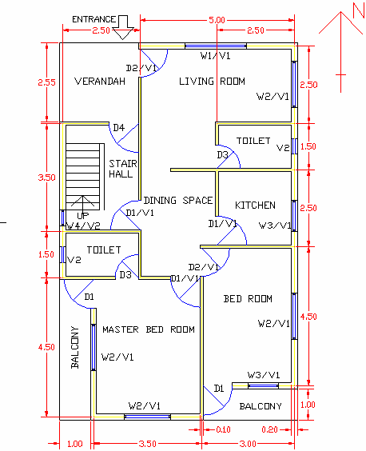

We qualified and experienced engineers help us to creating a plan in a construction company refers to the process of developing a detailed blueprint or roadmap for a construction project. This plan is a comprehensive document that outlines every aspect of the project from its inception to completion.

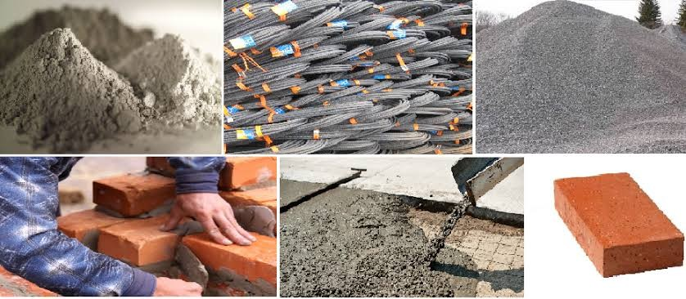

We choose quality materials to build a house involves various aspects, including:

Foundation: Opt for durable materials like reinforced concrete or treated wood for the foundation, ensuring stability.

Framing: Use strong and termite-resistant lumber for the framing of the house, such as pressure-treated wood.

Roofing: Select high-quality roofing materials like asphalt shingles, metal roofing, or clay tiles that are suitable for your climate and provide longevity.

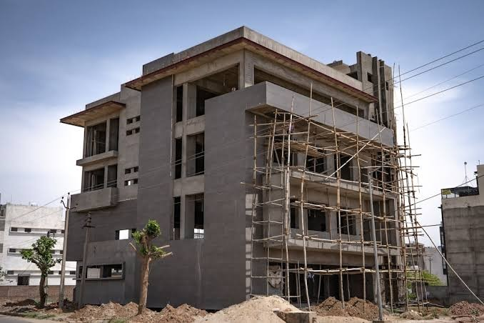

# EXTERIOR WORKS:

We craft exterior designs that go beyond aesthetics – they tell a story, create an impression, and transform spaces into living experiences tailored just for you.

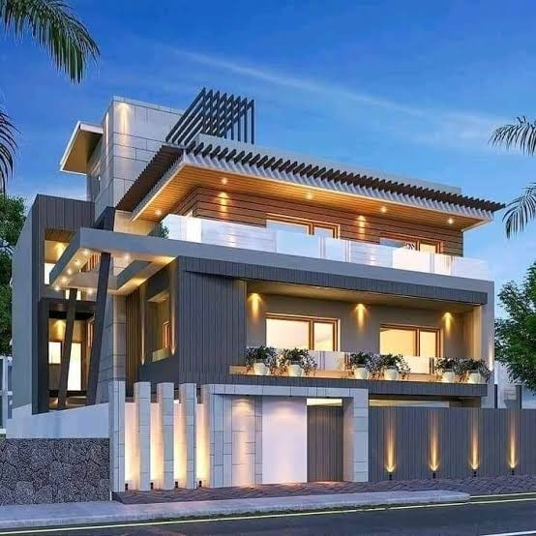

We’re not just builders; we’re architects of dreams. Our foundation is built on quality, commitment, and turning your vision into a concrete reality.”

We promise more than structures; we pledge a partnership. From groundbreaking to completion, trust us for unwavering quality, transparent communication, and a commitment to making your dream project a solid success.”

# FOR MORE INFORMATION :

Leave a Reply

B [log at WordPress.com.](https://wordpress.com/?ref=footer_blog)